Chelsea Ramsin
Project plan genome analysis

Aim of study

The aim of my project is to recreate the analysis from paper 3. The aim of that study is to assemble the genome of the bacteria Leptospirillum ferriphilum. The authors wanted to investigate how the bacteria adapts to new environments to get more understanding for how the bacteria can be used for biomining. Questions to be answered are: what is the genome of the species?, how does it adapt to an environment matching biomining conditions?

What type of analysis?

Table 1: Shows analysis and software needed as well as how long each analysis will approx take. The table also shows the data that is used in the analysis. The analysis are ordered from top to bottom and those with high run times are marked with red, those with low run times are marked with green and those marked with yellow are intermediate
Analysis | Software | Approx run time | Data used | Why?
Genome assembly | Canu | 11.5 h | Raw Pacbio reads | To assemble the genome
Assembly validation | MUMmerplot  or Quast | 15 min | fasta contigs | To see if the assembly is good
Annotation | Prokka  (maybe eggnog) | 15 min for Prokka  (1 hour for eggnog) | fasta contigs | To structurally and functionally annotate to give biological meaning to the genome
Synteny comparison | Artemis or ACT | ? | fasta contigs and fasta contigs from other species/strain | To check for synteny
Preprocess RNA | Trimmomatric | 15 min per file  (150 min total) | Raw transcripts | To clean up
RNA alignment | BWA | 5 h | Processed fasta transcripts and fasta contigs from genome
Read counting | Htseq | 8 h | RNA mapping data
Differential expression | DESeq2 | variable | Read counts

Time frame

Table 2: Rough schedule for each lab session. Analysis with long runtimes are planned to be performed the lab session before the results are to be analyzed so that I do not have to spend an entire day just waiting.
Day | What to do | Deadlines
2021-04-09 | Assemble genome
2021-04-14 | Evaluate genome and analyze the results. Start annotation
2021-04-15 | Analyze annotation results and do a whole analysis of the genome | Genome assembly + genome annotation
2021-04-20 | Run synteny visualization, analyze synteny
2021-04-28 | Run trimmomatric and analyze results. Start RNA alignment
2021-04-29 | analyze mapped RNA, run read counting
2021-05-03 | Analyze read counting, run diff expression
2021-05-04 | Analyze diff expression. | RNA mapping
2021-05-11 | Perform any extra analysis
2021-05-17 | Perform any extra analysis
2021-05-19 | Finish analysis

Data info

I will be handling PacBio long read DNA sequencing data as well as Illumina RNA sequence data.

DNA raw data is 10751 Mb https://www.ncbi.nlm.nih.gov/bioproject/?term=PRJEB21703
RNA raw data is 22601 Mb https://www.ncbi.nlm.nih.gov/bioproject/?term=PRJEB21842

Minimum of storage data is around 30 Gb bit since the results from different analysis will take up space as well, I probably would need at least the double.

Data organisation

I will organize my data by keeping code and commands in the Github repository, along with other small files relating to the project. Like the project plan. In UPPMAX, I will keep all of my files in different folders so that it is easy to find each file. The organization will be similar to figure 1 but will probably change along the way.

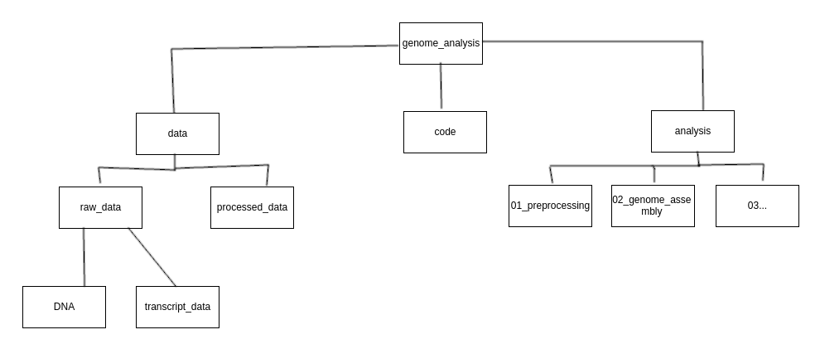Figur 1: Folder organization

